BOSS - global business competition
Do you dream of gaining practical experience in managing a company? Do you want to test your business skills and compete with the best students from around the world? If so, BOSS is a competition created just for you!

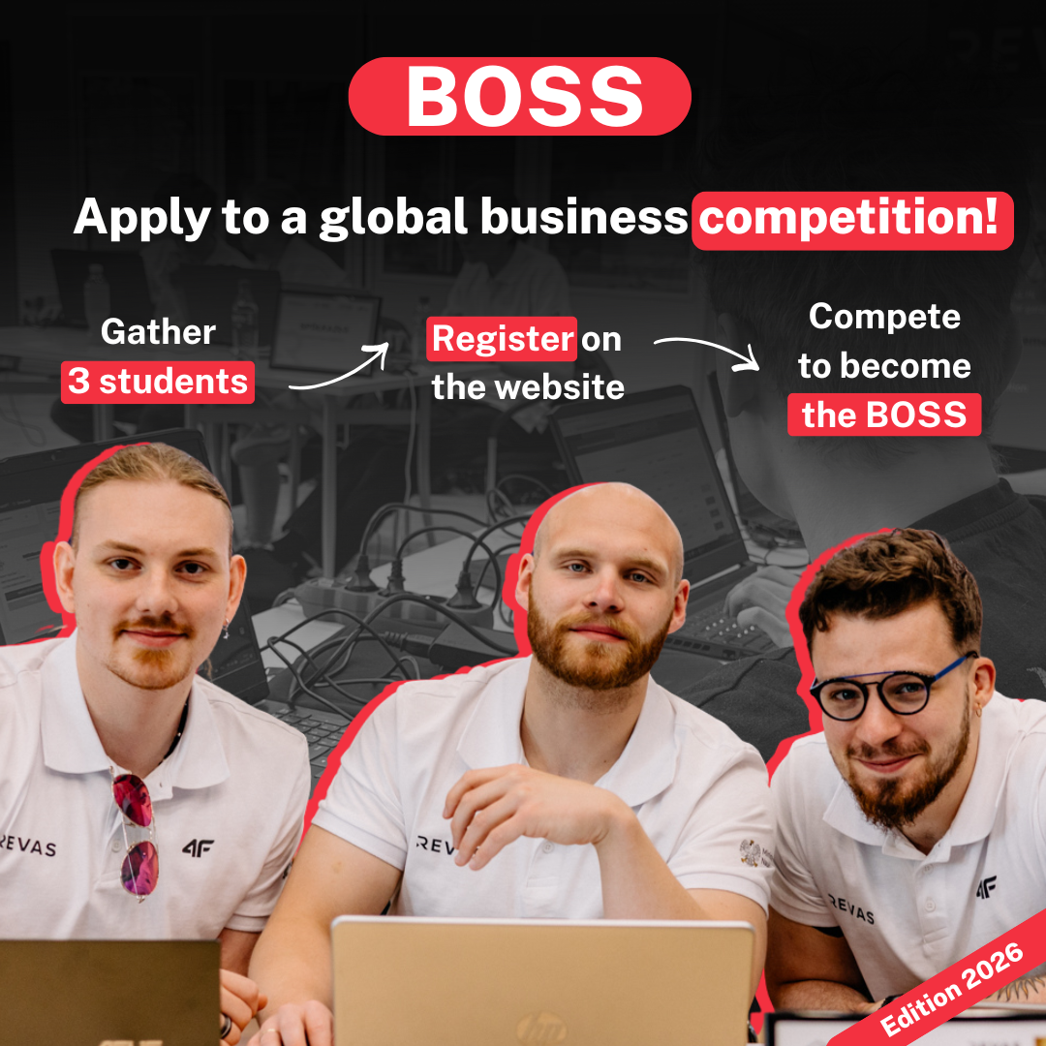

What is BOSS?
BOSS is a global, free business competition in which 3-person teams of students under the supervision of a lecturer (team supervisor) take on the role of entrepreneurs and manage their own, virtual enterprise. Using Revas Business Simulation Games, participants make realistic decisions in areas such as finance, marketing, sales, HR and investments. The competition allows you to gain valuable knowledge that can be used in your future professional career.

Why is it worth taking part?

Practical experience – you learn by doing, analyzing the effects of your business decisions.

Free participation – the competition is completely free!

Attractive prizes – prize pool of EUR 2,000!

Competence development – ​​you will improve your analytical, strategic and decision-making skills.

What is the course of the competition?

Registration of teams - the lecturer registers a team of 3 students for the competition using the form on the BOSS website. [January 26 - February 28, 2026]

Competition - participants make strategic decisions and compete with other teams. [March 9 - April 19, 2026]

Announcement of results - the best teams receive prizes.

How to register?
The registration is done by the lecturer (team supervisor). The number of student teams from one university is a maximum of 3. NOTE! One lecturer can enter 1 team. The registration deadline is February 28, 2026.
The application form and details about the competition details can be found on the BOSS website.

Join the best students!
Don't miss the opportunity to develop your business skills, gain valuable experience and fight for the prestigious title of BOSS! This is a great opportunity for both students and lecturers who want to get involved in an event using innovative, practical teaching methods.
Don't wait - register your team today and prove that YOU are the best BOSS!

